# Mail Flow – v1

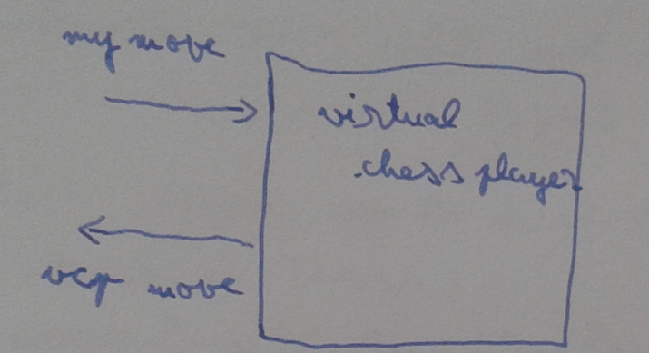

Flow:

[white moves]

Incomming data: whiteMove + new bitboards

If(moveIsLegal(whiteMove))

If(isNotCheckMate())

generateNextMove()